CHAPTER 9 - MODULES
TOPICS COVERED
9.1 WHAT IS A MODULE
9.2 RULES TO USE PYTHON PROGRAM AS MODULE
9.3 BENEFITS OF USING MODULES
9.4 TYPES OF MODULE IMPORTATION
9.5 DIFFERENT TYPES OF MODULES

9.1 WHAT IS A MODULE
- Python modules are same as standard code library.
- A Module is a file which contains different python statements and definitions
- A Module is a code library file which also includes many runnable codes.
- A Module can define functions, classes and variables.
- In simple words, modules are existing python programs that have been run at least once.
9.2 RULES TO USE PYTHON PROGRAMS AS MODULE
- Save python program with specific name followed by .py extension
- Run the program at least once
- Use import statement at the beginning of a new script
- Immediately followed that, give specific file you want to add in your current application without python extension.
[Note: if a previous runnable code is imported with python extension then it returns an error message received from default exception hierarchy]
9.3 BENEFITS OF USING MODULES
- Memory optimization
- Code Reusability
- Optimized memory utilization
- Code utilization

9.4 TYPES OF MODULE IMPORTATION
There are three types of module importation available in python,
- Type1: Import module name [Ex: import tkinter ]
- Type2: From module name import * [Ex: from tkinter import * ]
- Type3: From module name import specific function name [Ex: from tkinter import Image ]
[Note: Type 2 is used to invoke all the available function of a module with current global name space where as type3 is used to invoke a specific function from a module with in current name space]

9.5 DIFFERENT TYPES OF MODULES
9.5.1 OS MODULE
9.5.2 SYS MODULE
9.5.3 RANDOM MODULE
9.5.4 TIME MODULE
9.5.5 DATETIME MODULE
9.5.6 CALENDAR MODULE

9.5.1 OS MODULE
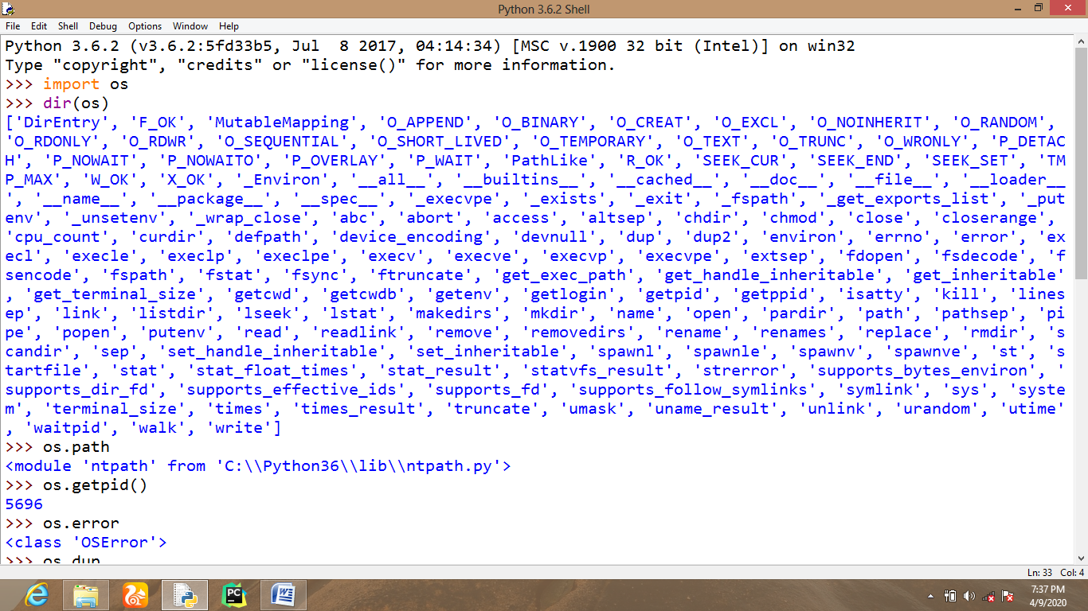
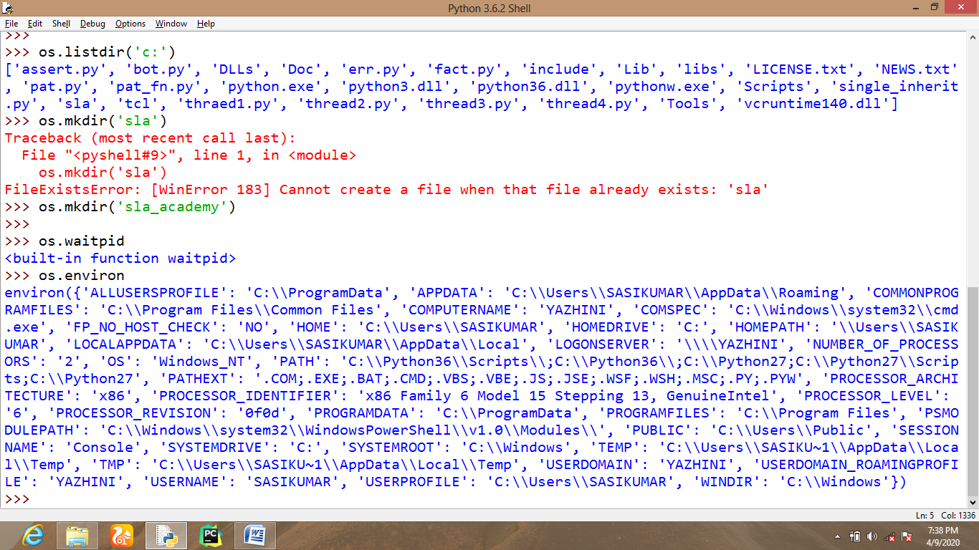
9.5.2 SYS MODULE
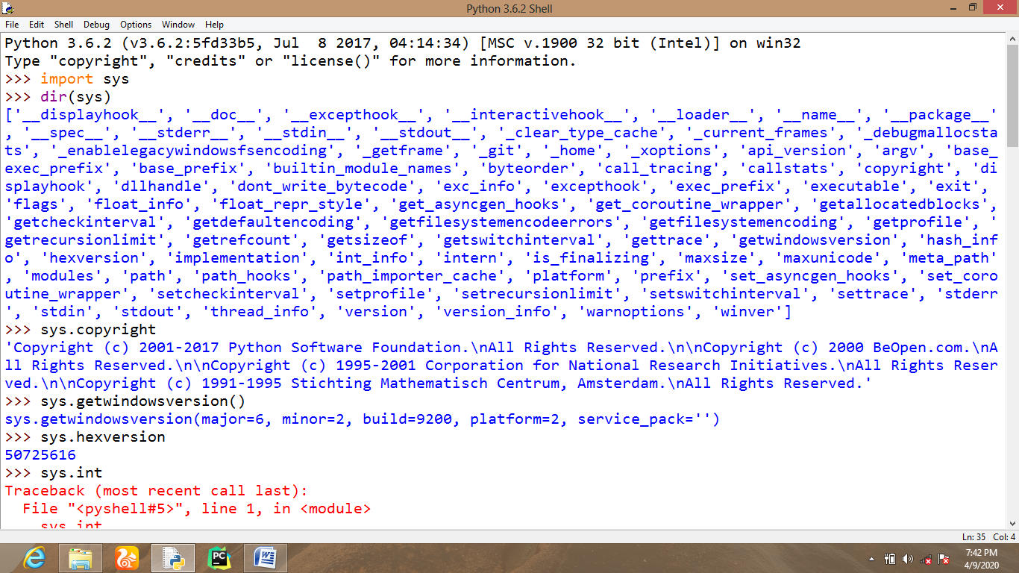
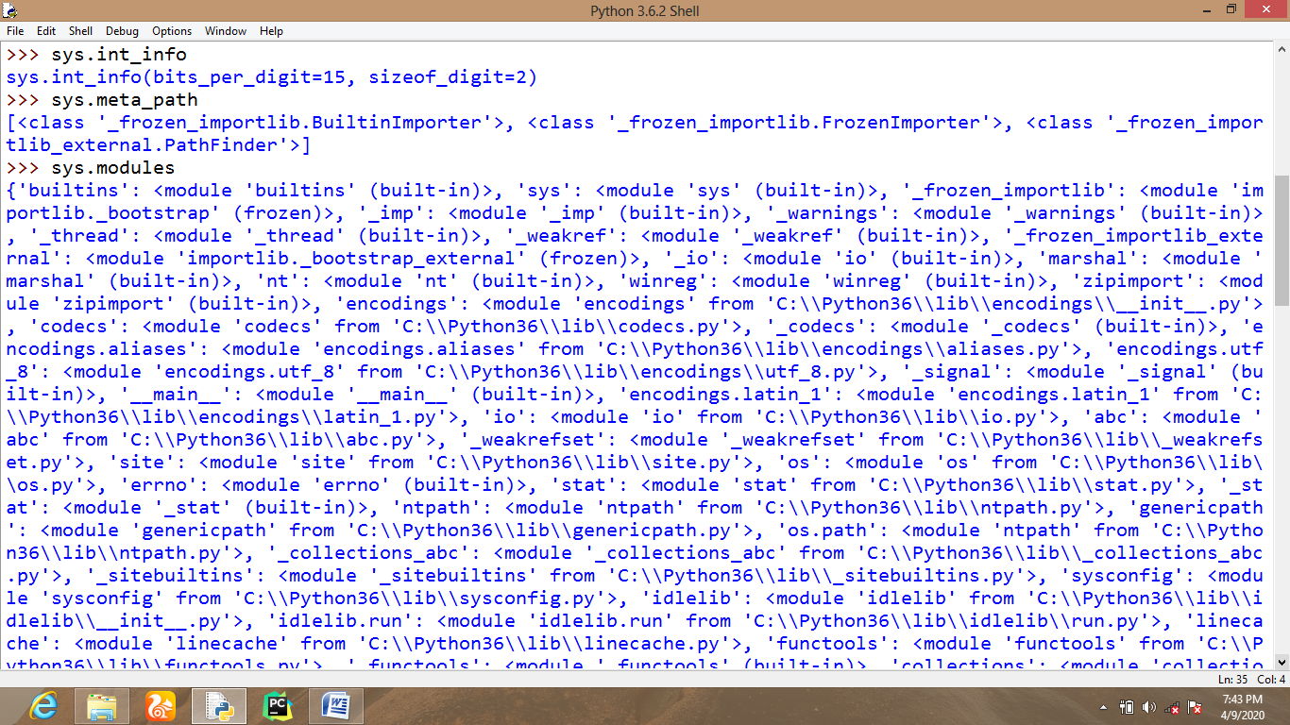
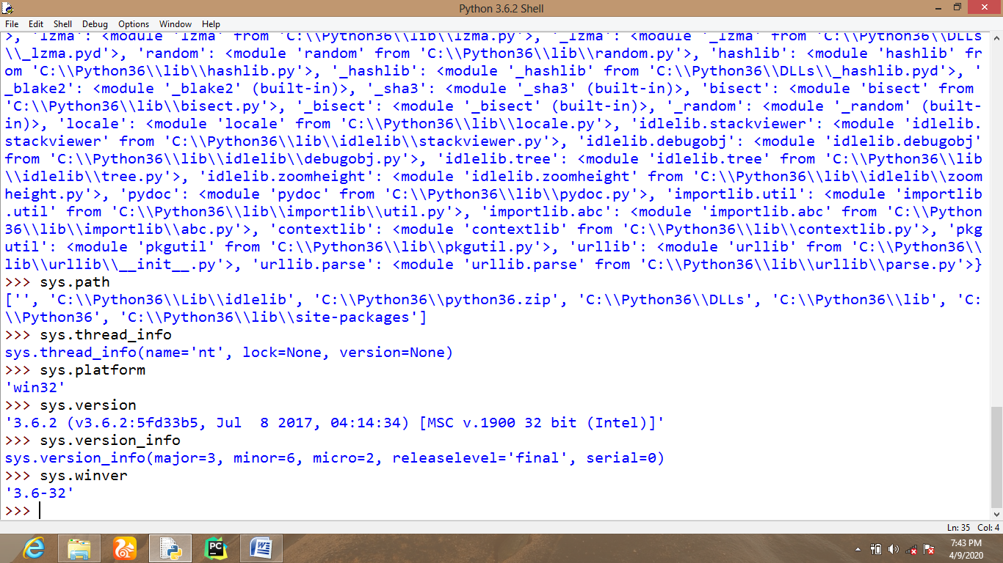
9.5.3 RANDOM MODULE
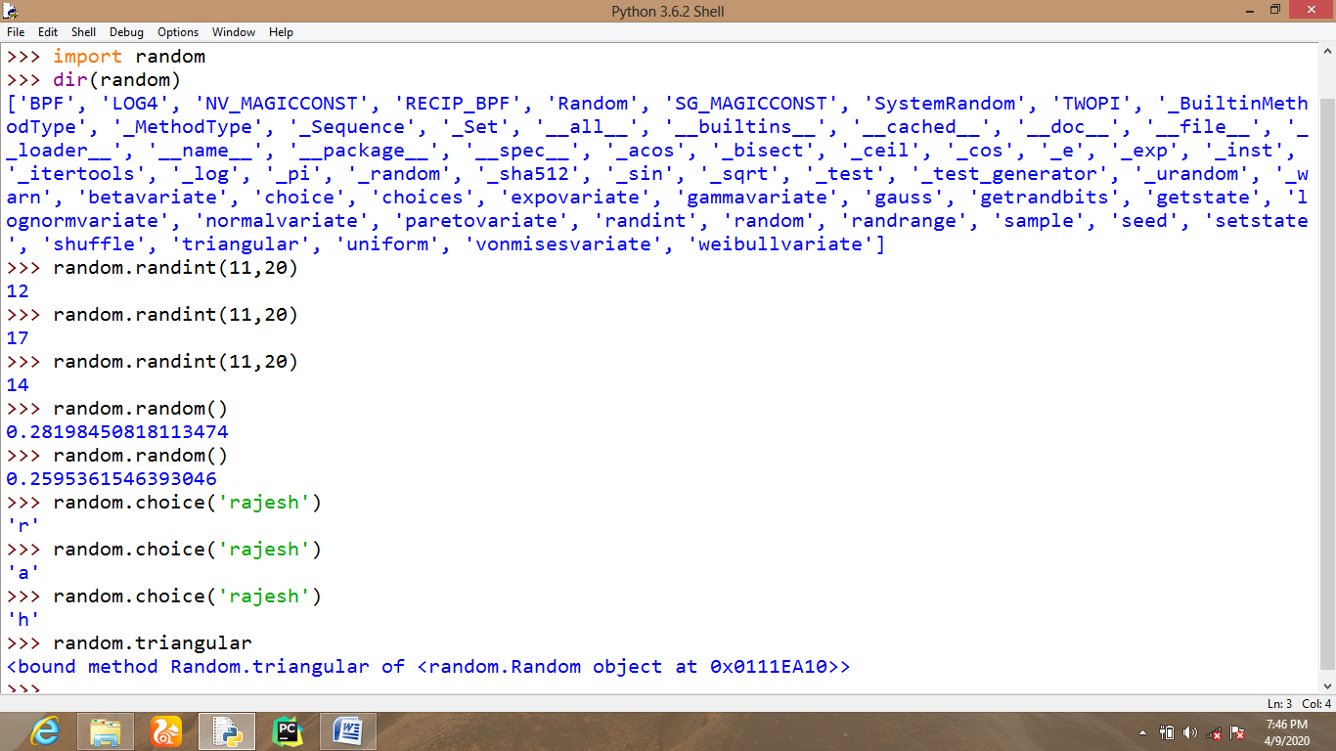
9.5.4 TIME MODULE
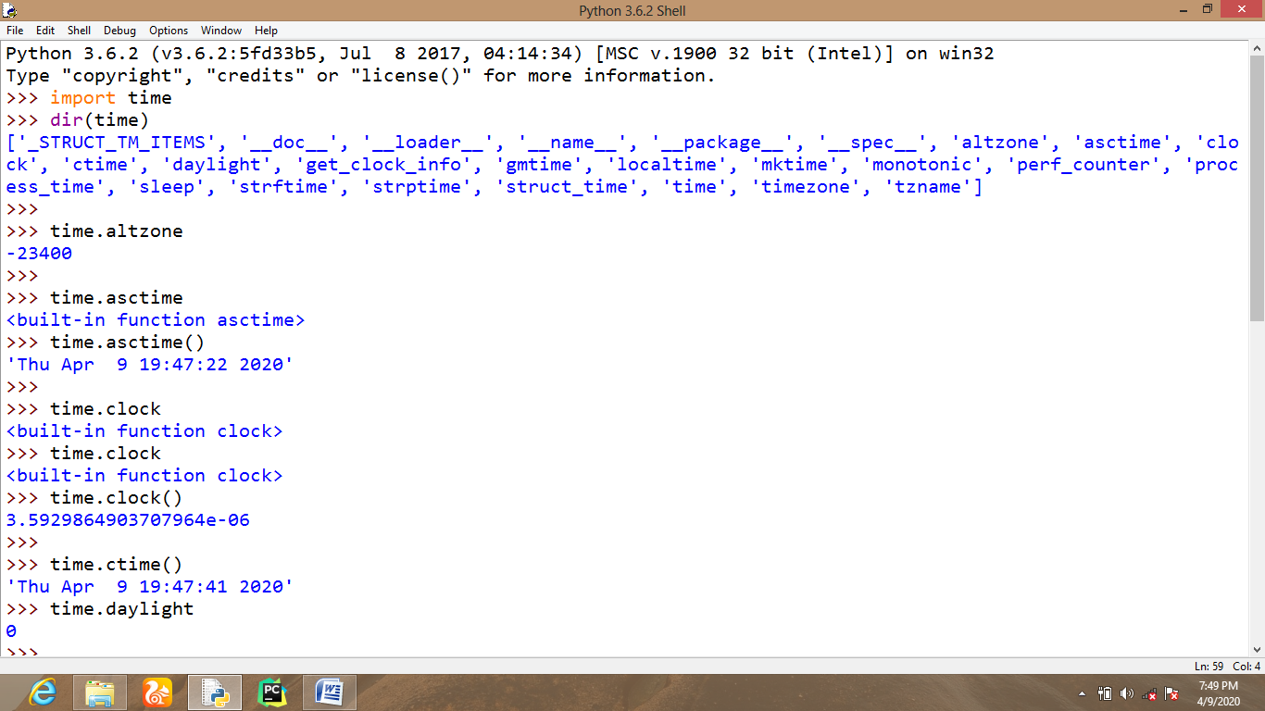
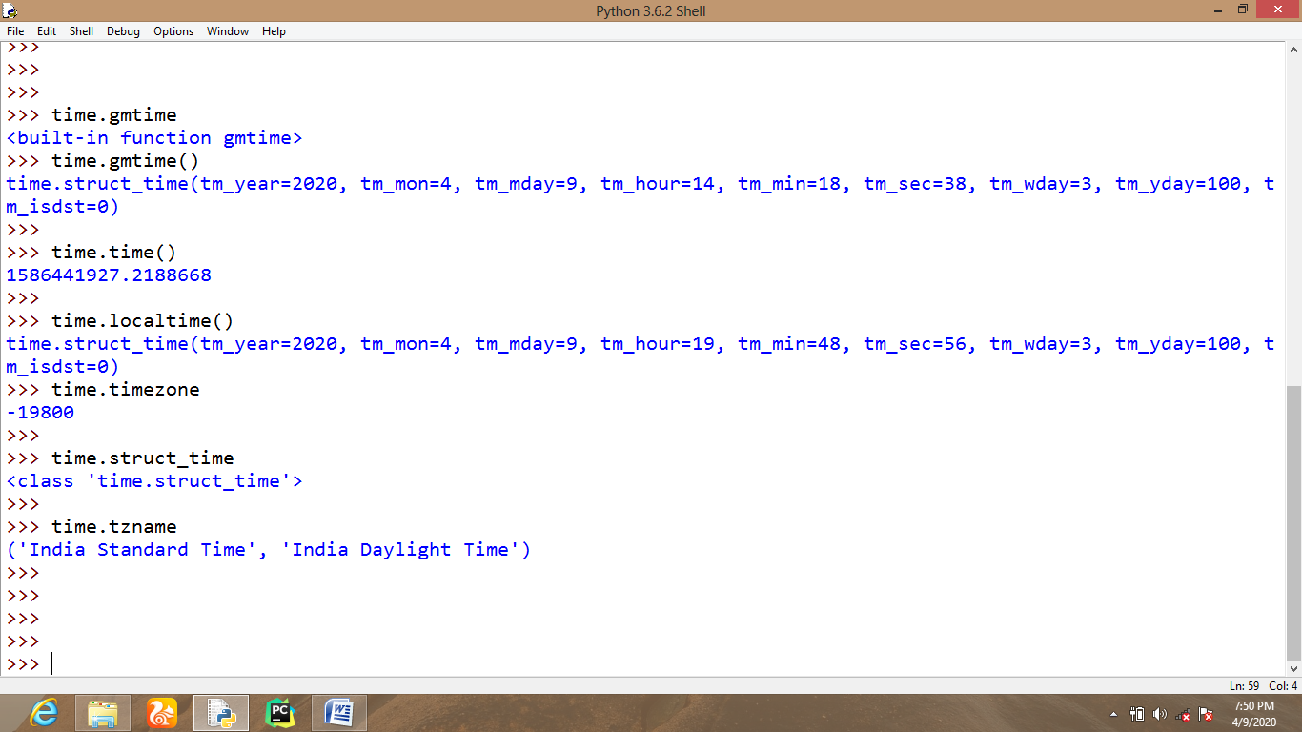
9.5.5 DATETIME MODULE
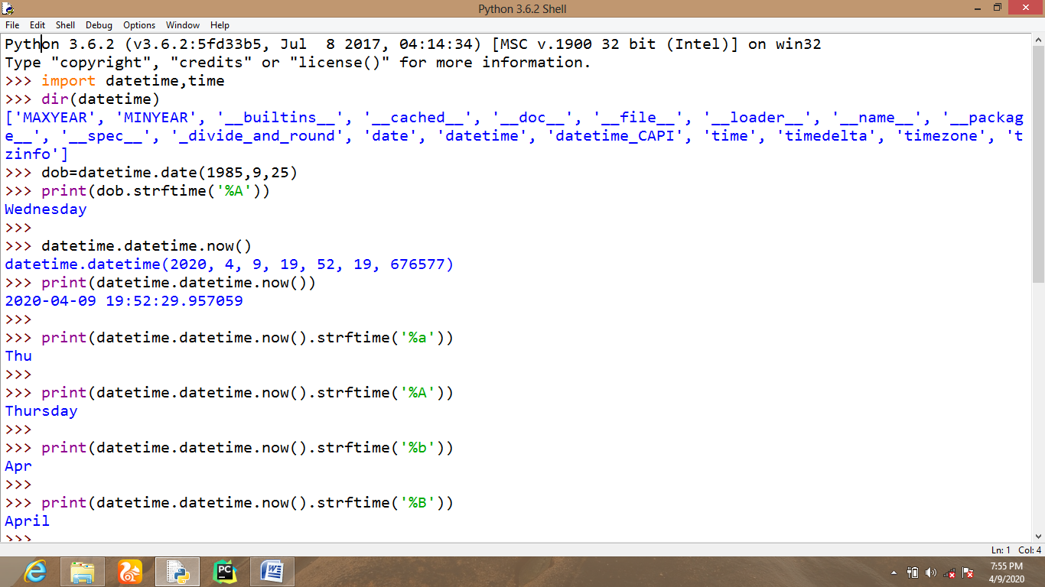
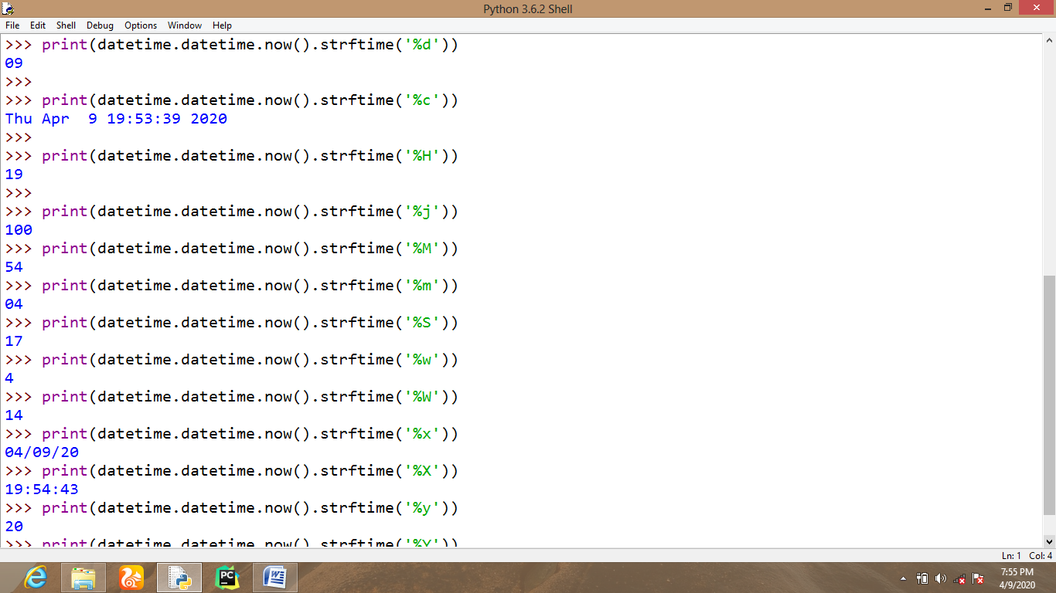
9.5.6 CALENDAR MODULE
